XCRAM
Use Case Specification

Submitted to:

Asst. Prof. Ma. Rowena C. Solamo
Faculty Member
Department of Computer Science
College of Engineering
University of the Philippines, Diliman

Submitted by:
Agluba, Gerry P.
Go, Sharleen Joy Y.
Silverio, Robelle C.

In partial fulfillment of academic requirements for the course

CS 191 Software Engineering I of the

1st Semester, AY 2016-2017

System: Task Scheduling System Page: 1
Version: 2.0 Group: TaskOverflow
Unique Reference:

The documents are stored in the https://github.com/sharleengo/XCRAM/tree/master/02-Requirements-Engineering

Document Purpose:

The purpose of this document is to present the use case specification of ‘View Current Schedule’ use case.

Target Audience:

Evaluators and users.

Revision Control

History Revision:
Revision | Person | Version | Modification
Date | Responsible | Number
09/28/16 | Robelle Silverio | 1.0 | Specified purpose, target audience, use case
 |  |  | name, use case precondition, flow of events
 |  |  | (scenarios along with its description). Added
 |  |  | activity diagram.
09/28/16 | Sharleen Joy Go | 1.1 | Added use case description.
09/28/16 | Robelle Silverio | 1.2 | Edited use case description.
11/22/16 | Robelle Silverio | 2.0 | Edited unique reference and use case name

System: Task Scheduling System Page: 2
Version: 2.0 Group: TaskOverflow

Use-Case Name:

Description:

Use-Case 3.0 View Current Schedule

This use-case will allow the User to view the schedule for the entire day that the system has made given all the User's inputs. Each task's title will appear alongside its allotted time range and they will be sorted in increasing order of time.

It uses military time which starts from 12:00 and ends at 23:59.

Preconditions: | None
Flow of Events:
Scenario Name |  |  | Description
Scenario 1 (Basic Flow) |  | 1. The User chooses to view his/her current schedule.
User chose to view current |  | 2. The entire schedule is shown.
schedule and hides the |  | 3. | Each block could be a block with task title (a task for that day) or a free
schedule after viewing it |  | 3.
schedule after viewing it |  | task block (no task assigned) which corresponds with a specific time range.
 |  | 4. | Uses military time.
 |  | 5. | One day means 00:00 to 23:59.
 |  | 6. | When user decided to hide the schedule, schedule is no longer
 |  | displayed.
Scenario 2 |  | 1. The User chooses to view his/her current schedule.
User chose to view current |  | 2. The entire schedule is shown.
schedule and didn’t hide the |  | 3. | Each block could be a block with task title (a task for that day) or a free
schedule as he/she views it |  | 3.
 |  | task block (no task assigned) which corresponds with a specific time range.
 |  | 4. | Uses military time.
 |  | 5. | One day means 00:00 to 23:59.
 |  | 6. | When user decided not to hide the schedule, schedule is still displayed.

System: Task Scheduling System Page: 3
Version: 2.0 Group: TaskOverflow
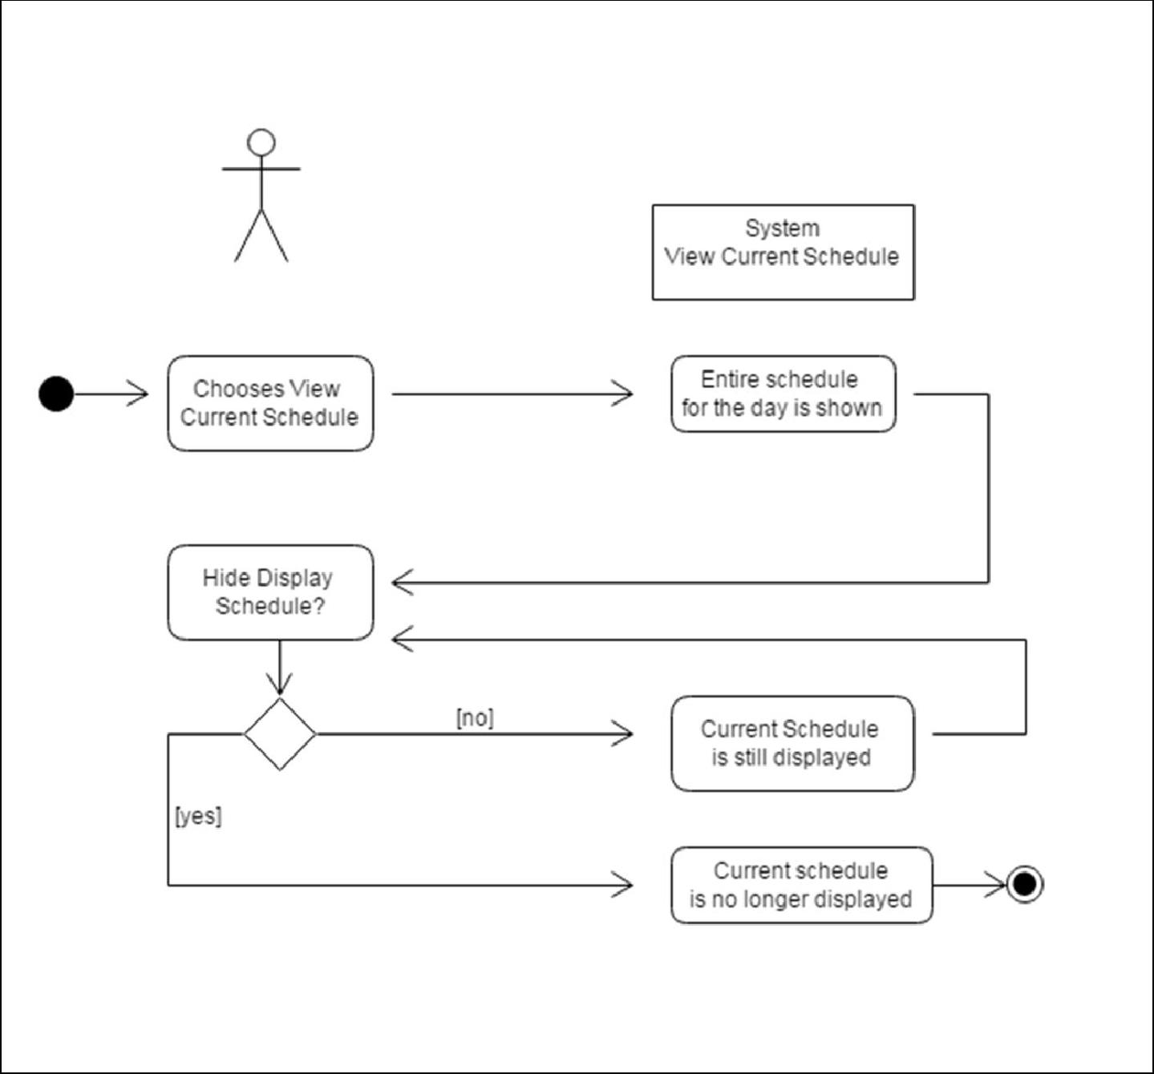

user

Activity Diagram of the flow of events:

System: Task Scheduling System Page: 4
Version: 2.0 Group: TaskOverflow
Post Condition: None

Relationship: None

Special Requirements: None

System: Task Scheduling System Page: 5
Version: 2.0 Group:TaskOverflow

